Recommended Reading
We recommend beginning with the top four books, if you haven’t already read them
 | Title | Author | Read?
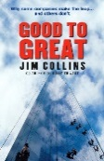 | Good to Great | Jim Collins
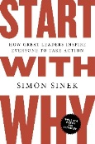 | Start with Why | Simon Sinek
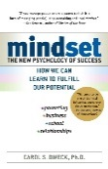 | Mindset | Carol Dweck
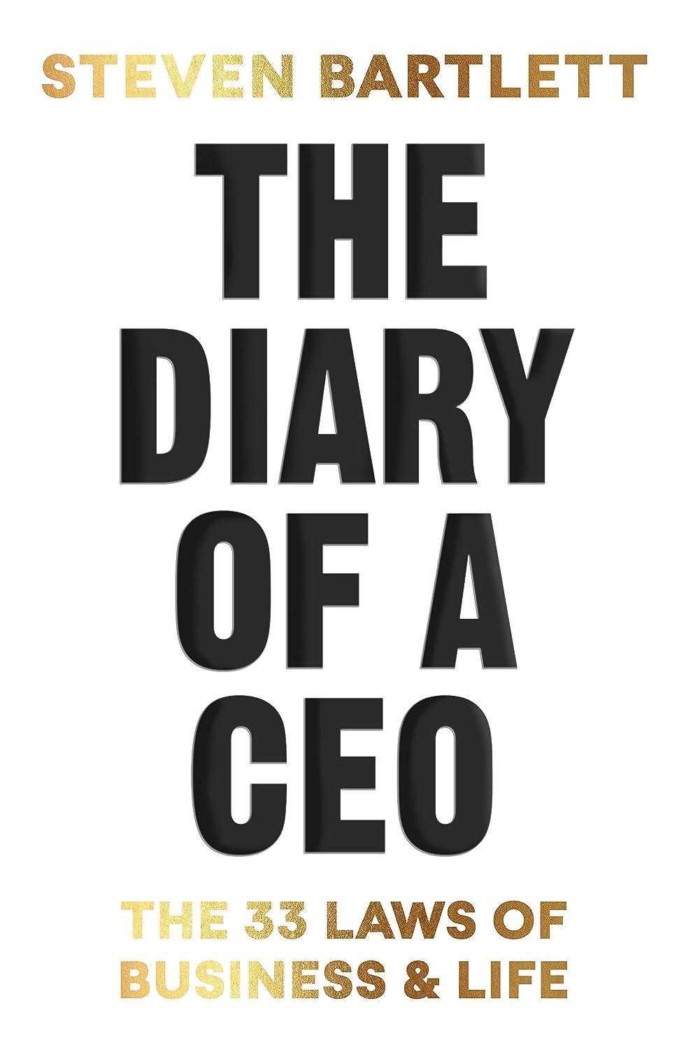 | The Diary of a CEO | Steven Bartlett
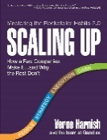 | Scaling Up | Verne Harnish
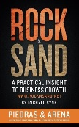 | Rock and Sand | Michael Synk
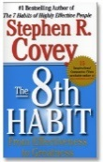 | The 8th Habit | Stephen Covey

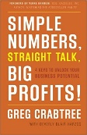 | Simple Numbers | Greg Crabtree
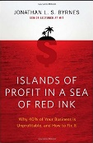 | Islands of Profit in a Sea of Red Ink | Jonathan L S Byrnes
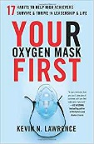 | Your Oxygen Mask First | Kevin Lawrence
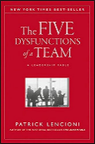 | Five Dysfunctions of a Team | Pat Lencioni
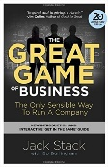 | The Great Game of Business | Jack Stack
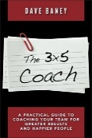 | The 3x5 Coach | Dave Baney
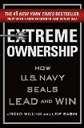 | Extreme Ownership | Jocko Willink and Leif Babin
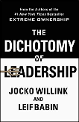 | The Dichotomy of Leadership | Jocko Willink and Leif Babin

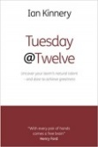 | Tuesday at Twelve | Ian Kinnery
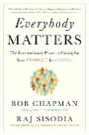 | Everybody Matters | Bob Chapman
 | The Infinite Game | Simon Sinek
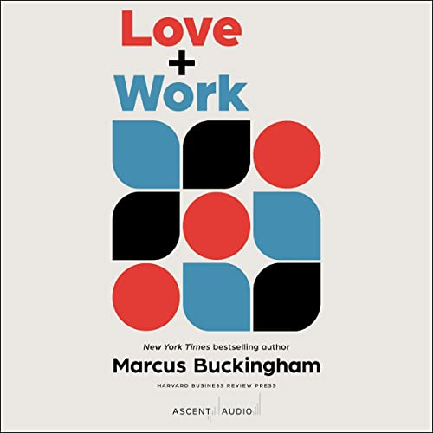 | Love and Work | Marcus Buckingham
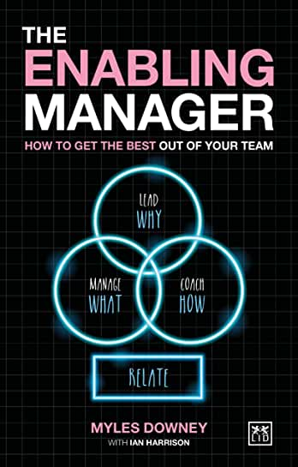 | The Enabling Manager | Myles Downey
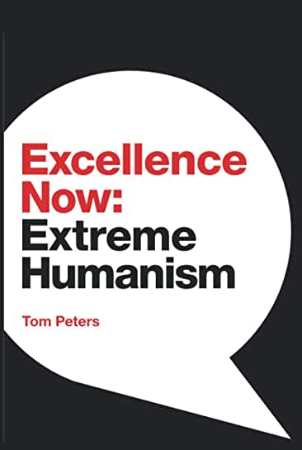 | Excellence now;  Extreme Humanism | Tom Peters
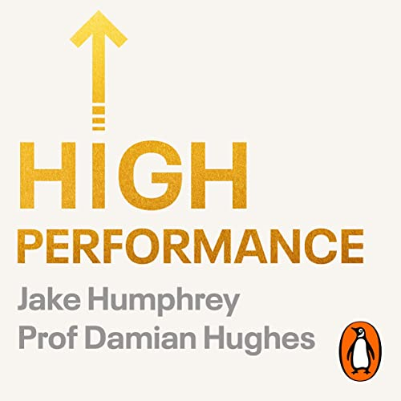 | High Performance | Jake Humphrey & Prof Damian Hughes
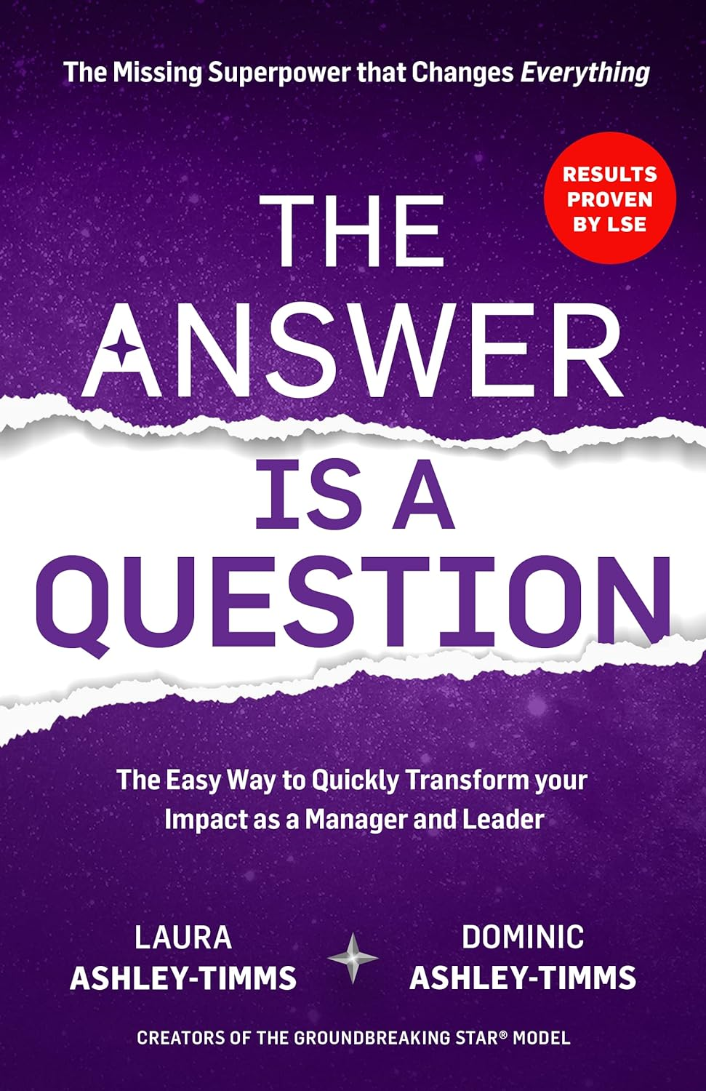 | The Answer is a Question | Laura a & Dominic Ashley-Timms
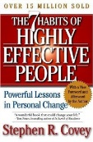 | The 7 Habits of Highly Effective People | Stephen Covey
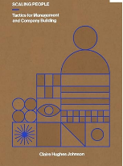 | Scaling People: tactics for Management and Company Building | Claire Hughes Johnson
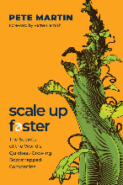 | Scale up faster | Pete Martin
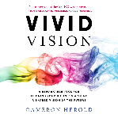 | Vivid Vision | Cameron Herold
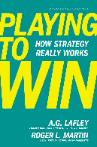 | Playing to Win | Lafley & Martin
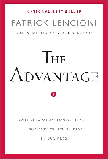 | The Advantage | Pat Lencioni

